**SAMPLE CODING**

**Activity_main.xml**

*<?*xml version="1.0" encoding="utf-8"*?>*<androidx.constraintlayout.widget.ConstraintLayout xmlns:android="http://schemas.android.com/apk/res/android"  
 xmlns:app="http://schemas.android.com/apk/res-auto"  
 xmlns:tools="http://schemas.android.com/tools"  
 android:layout_width="match_parent"  
 android:layout_height="match_parent"  
 tools:context=".MainActivity">  
  
 <TextView  
 android:id="@+id/playerOne"  
 android:layout_width="wrap_content"  
 android:layout_height="wrap_content"  
 android:text="Player One"  
 android:layout_marginTop="5dp"  
 android:layout_marginLeft="15dp"  
 android:textSize="20sp"  
 app:layout_constraintTop_toTopOf="parent"  
 app:layout_constraintLeft_toLeftOf="parent"  
 />  
  
 <TextView  
 android:id="@+id/playerOneScore"  
 android:layout_width="wrap_content"  
 android:layout_height="wrap_content"  
 android:text="0"  
 android:textSize="25sp"  
 app:layout_constraintLeft_toLeftOf="@+id/playerOne"  
 app:layout_constraintTop_toBottomOf="@+id/playerOne"  
 app:layout_goneMarginLeft="40dp" />  
  
 <TextView  
 android:id="@+id/playerTwo"  
 android:layout_width="wrap_content"  
 android:layout_height="wrap_content"  
 android:text="Player Two"  
 android:textSize="20sp"  
 app:layout_constraintTop_toTopOf="parent"  
 app:layout_constraintRight_toRightOf="parent"  
 app:layout_goneMarginRight="15dp"  
 app:layout_goneMarginTop="5dp"  
 />  
 <TextView  
 android:id="@+id/playerTwoScore"  
 android:layout_width="wrap_content"  
 android:layout_height="wrap_content"  
 android:text="0"  
 android:textSize="25dp"  
 app:layout_constraintTop_toBottomOf="@+id/playerTwo"  
 app:layout_constraintRight_toRightOf="@+id/playerTwo"  
 android:layout_marginRight="35dp"  
 />  
  
 <TextView  
 android:id="@+id/playerStatus"  
 android:layout_width="match_parent"  
 android:layout_height="wrap_content"  
 android:textSize="20sp"  
 android:textAlignment="center"  
 app:layout_constraintTop_toBottomOf="@+id/playerOneScore"  
 app:layout_constraintLeft_toLeftOf="parent"  
 app:layout_constraintRight_toRightOf="parent"  
 />  
  
 <Button  
 android:id="@+id/btn_0"  
 android:layout_width="135dp"  
 android:layout_height="135dp"  
 android:textSize="60sp"  
 android:textStyle="bold"  
 android:backgroundTint="#413F43"  
 android:textColor="#ffffff"  
 app:layout_constraintTop_toBottomOf="@+id/playerStatus"  
 app:layout_constraintLeft_toLeftOf="parent"  
 android:layout_marginLeft="3dp"  
 android:layout_marginTop="15dp"  
 />  
  
  
 <Button  
 android:id="@+id/btn_1"  
 android:layout_width="135dp"  
 android:layout_height="135dp"  
 android:textSize="60sp"  
 android:textStyle="bold"  
 android:backgroundTint="#413F43"  
 android:textColor="#ffffff"  
 app:layout_constraintTop_toTopOf="@+id/btn_0"  
 app:layout_constraintLeft_toRightOf="@+id/btn_0"  
  
 />  
  
 <Button  
 android:id="@+id/btn_2"  
 android:layout_width="135dp"  
 android:layout_height="135dp"  
 android:textSize="60sp"  
 android:textStyle="bold"  
 android:backgroundTint="#413F43"  
 android:textColor="#ffffff"  
 app:layout_constraintLeft_toRightOf="@+id/btn_1"  
 app:layout_constraintTop_toTopOf="@+id/btn_1" />  
 <Button  
 android:id="@+id/btn_3"  
 android:layout_width="135dp"  
 android:layout_height="135dp"  
 android:textSize="60sp"  
 android:textStyle="bold"  
 android:backgroundTint="#413F43"  
 app:layout_constraintTop_toBottomOf="@+id/btn_0"  
 app:layout_constraintLeft_toLeftOf="@+id/btn_0"  
  
 />  
  
 <Button  
 android:id="@+id/btn_4"  
 android:layout_width="135dp"  
 android:layout_height="135dp"  
 android:backgroundTint="#413F43"  
 android:textSize="60sp"  
 android:textStyle="bold"  
 app:layout_constraintTop_toTopOf="@+id/btn_3"  
 app:layout_constraintLeft_toRightOf="@+id/btn_3"  
  
 />  
  
 <Button  
 android:id="@+id/btn_5"  
 android:layout_width="135dp"  
 android:layout_height="135dp"  
 android:backgroundTint="#413F43"  
 android:textSize="60sp"  
 android:textStyle="bold"  
 app:layout_constraintLeft_toRightOf="@+id/btn_4"  
 app:layout_constraintTop_toTopOf="@+id/btn_4" />  
  
 <Button  
 android:id="@+id/btn_6"  
 android:layout_width="135dp"  
 android:layout_height="135dp"  
 android:textSize="60sp"  
 android:textStyle="bold"  
 android:backgroundTint="#413F43"  
 app:layout_constraintTop_toBottomOf="@+id/btn_3"  
 app:layout_constraintLeft_toLeftOf="@+id/btn_3"  
  
 />  
  
 <Button  
 android:id="@+id/btn_7"  
 android:layout_width="135dp"  
 android:layout_height="135dp"  
 android:backgroundTint="#413F43"  
 android:textSize="60sp"  
 android:textStyle="bold"  
 app:layout_constraintTop_toTopOf="@+id/btn_6"  
 app:layout_constraintLeft_toRightOf="@+id/btn_6"  
 />  
  
 <Button  
 android:id="@+id/btn_8"  
 android:layout_width="135dp"  
 android:layout_height="135dp"  
 android:backgroundTint="#413F43"  
 android:textSize="60sp"  
 android:textStyle="bold"  
 app:layout_constraintTop_toTopOf="@+id/btn_7"  
 app:layout_constraintLeft_toRightOf="@+id/btn_7"  
  
 />  
  
 <Button  
 android:id="@+id/resetGame"  
 android:layout_width="wrap_content"  
 android:layout_height="60dp"  
 android:layout_marginTop="36dp"  
 android:backgroundTint="#E1470D"  
 android:text="Reset Game"  
 android:textColor="#ffffff"  
 android:textSize="20dp"  
 android:textStyle="bold"  
 app:layout_constraintLeft_toLeftOf="parent"  
 app:layout_constraintRight_toRightOf="parent"  
 app:layout_constraintTop_toBottomOf="@+id/btn_6" />  
</androidx.constraintlayout.widget.ConstraintLayout>

**Main_Activity.java**

package com.example.tictactoeapp;  
  
import androidx.appcompat.app.AppCompatActivity;  
  
import android.graphics.Color;  
import android.os.Bundle;  
import android.util.Log;  
import android.view.View;  
import android.widget.Button;  
import android.widget.TextView;  
import android.widget.Toast;  
  
public class MainActivity extends AppCompatActivity implements View.OnClickListener {  
  
 private TextView playerOneScore, playerTwoScore, playerStatus;  
 private Button [] buttons = new Button[9];  
 private Button resetGame;  
  
 private int playerOneScoreCount, playerTwoScoreCount, rountCount;  
 boolean activePlayer;  
  
 *//p1 => 0  
 //p2 => 1  
 //empty => 2* int [] gameState ={2,2,2,2,2,2,2,2,2,};  
  
 int [][] winningPositions = {  
 {0,1,2},{3,4,5},{6,7,8}, *//rows* {0,3,6},{1,4,7},{2,5,8}, *//columns* {0,4,8},{2,4,6} *//cross* };  
 @Override  
 protected void onCreate(Bundle savedInstanceState) {  
 super.onCreate(savedInstanceState);  
 setContentView(R.layout.*activity_main*);  
  
 playerOneScore = (TextView) findViewById(R.id.*playerOneScore*);  
 playerTwoScore = (TextView) findViewById(R.id.*playerTwoScore*);  
 playerStatus = (TextView) findViewById(R.id.*playerStatus*);  
  
 resetGame = (Button) findViewById(R.id.*resetGame*);  
  
 for(int i=0; i < buttons.length; i++){  
 String buttonID = "btn_" + i;  
 int resourceID = getResources().getIdentifier(buttonID, "id", getPackageName());  
 buttons[i] = (Button) findViewById(resourceID);  
 buttons[i].setOnClickListener(this);  
 }  
  
 rountCount =0;  
 playerOneScoreCount =0;  
 playerTwoScoreCount =0;  
 activePlayer = true;  
  
 }  
  
 @Override  
 public void onClick(View v) {  
 if(!((Button)v).getText().toString().equals("")){  
 return;  
 }  
 String buttonId = v.getResources().getResourceEntryName(v.getId());*//btn_2* int gameStatePointer = Integer.*parseInt*(buttonId.substring(buttonId.length()-1, buttonId.length()));*//2* if (activePlayer) {  
 ((Button) v).setText("X");  
 ((Button) v).setTextColor(Color.*parseColor*("#FFC34A"));  
 gameState[gameStatePointer] = 0;  
 }else {  
 ((Button) v).setText("O");  
 ((Button) v).setTextColor(Color.*parseColor*("#70FFEA"));  
 gameState[gameStatePointer] = 1;  
  
 }  
 rountCount++;  
  
 if (checkWinner()){  
 if (activePlayer){  
 playerOneScoreCount++;  
 UpdatePlayerScore();  
 Toast.*makeText*(this, "Player One Won!", Toast.*LENGTH_SHORT*).show();  
 playAgain();  
 }else {  
 playerTwoScoreCount++;  
 UpdatePlayerScore();  
 Toast.*makeText*(this, "Player One Won!", Toast.*LENGTH_SHORT*).show();  
 playAgain();  
  
 }  
 }else if(rountCount == 9){  
 playAgain();  
 Toast.*makeText*(this, "No Winner!", Toast.*LENGTH_SHORT*).show();  
  
  
 }else {  
 activePlayer = !activePlayer;  
 }  
 if(playerOneScoreCount > playerTwoScoreCount){  
 playerStatus.setText("player One is winning!");  
 }else if (playerTwoScoreCount > playerOneScoreCount){  
 playerStatus.setText("Player Two is Winning!");  
 }else{  
 playerStatus.setText("");  
 }  
  
 resetGame.setOnClickListener(new View.OnClickListener() {  
 @Override  
 public void onClick(View view) {  
 playAgain();  
 playerOneScoreCount = 0;  
 playerTwoScoreCount = 0;  
 playerStatus.setText("");  
 UpdatePlayerScore();  
 }  
 });  
  
 }  
  
 private void updatePlayerScore() {  
 }  
  
 public boolean checkWinner(){  
 boolean winnerResult = false;  
  
 for (int [] winningPosition : winningPositions){  
 if (gameState[winningPosition[0]] == gameState[winningPosition[1]] &&  
 gameState[winningPosition[1]] == gameState[winningPosition[2]] &&  
 gameState[winningPosition[0]] !=2) {  
 winnerResult = true;  
  
 }  
 }  
 return winnerResult;  
  
 }  
  
 public void UpdatePlayerScore(){  
 playerOneScore.setText(Integer.*toString*(playerOneScoreCount));  
 playerTwoScore.setText(Integer.*toString*(playerTwoScoreCount));  
 }  
  
 public void playAgain(){  
 rountCount = 0;  
 activePlayer = true;  
  
 for (int i = 0; i < buttons.length; i++){  
 gameState[i] = 2;  
 buttons[i].setText((""));  
 }  
 }  
  
 }

APPENDIX 2

SCREEN SHOTS

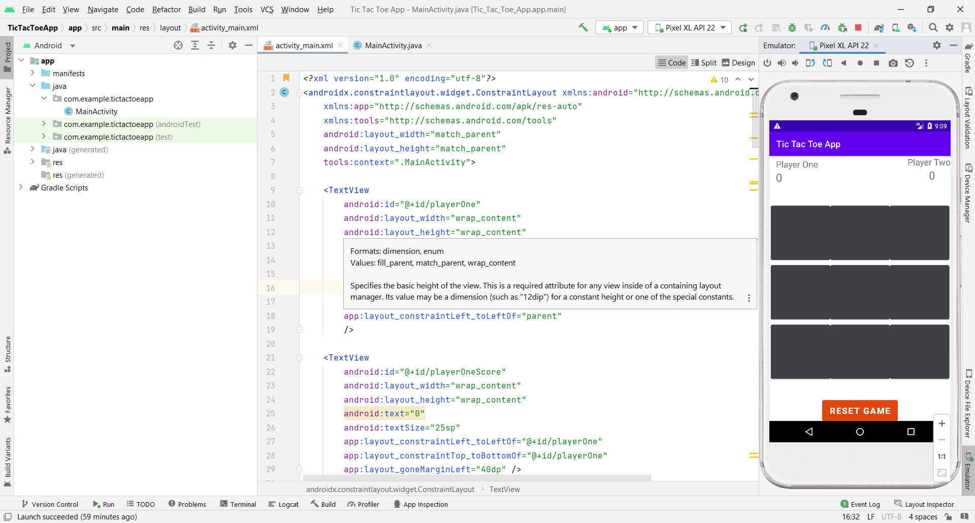

figA.2.1 initial design of tic tac toe application

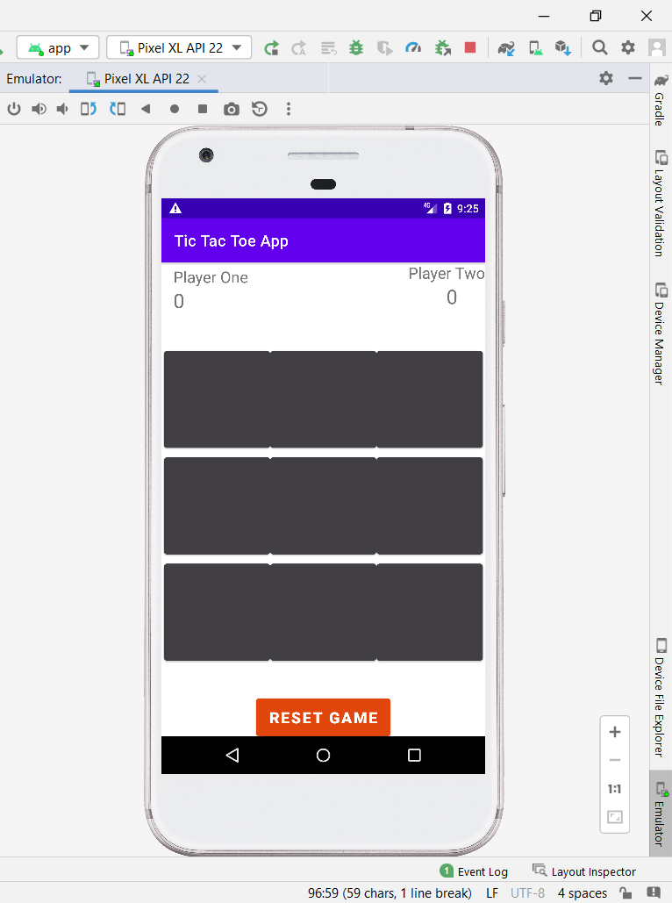

Fig.A.2 initial stage of the diagram

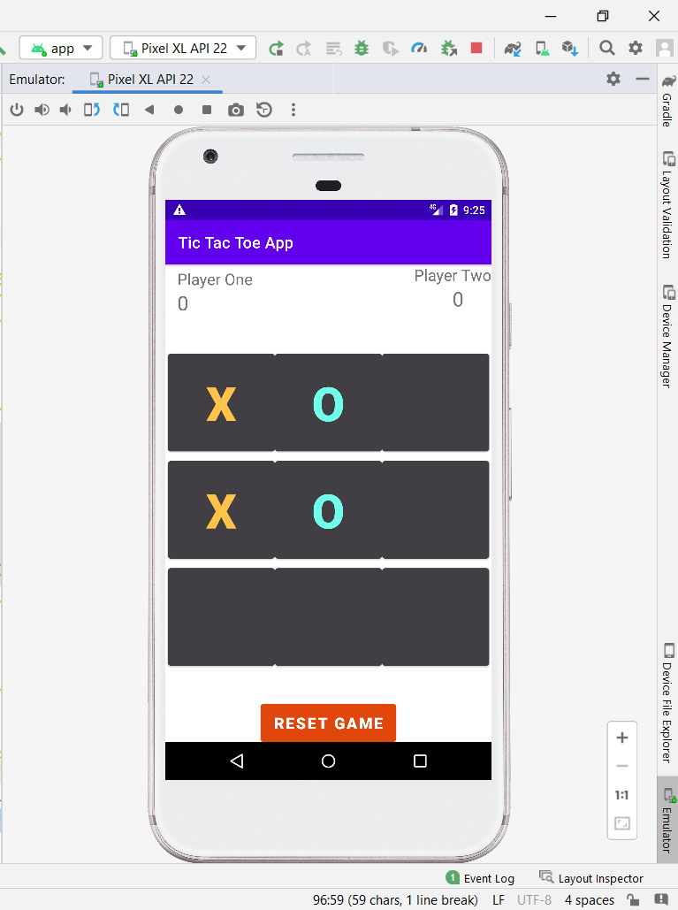

Fig.A.3 both player 1 and player 2 playing

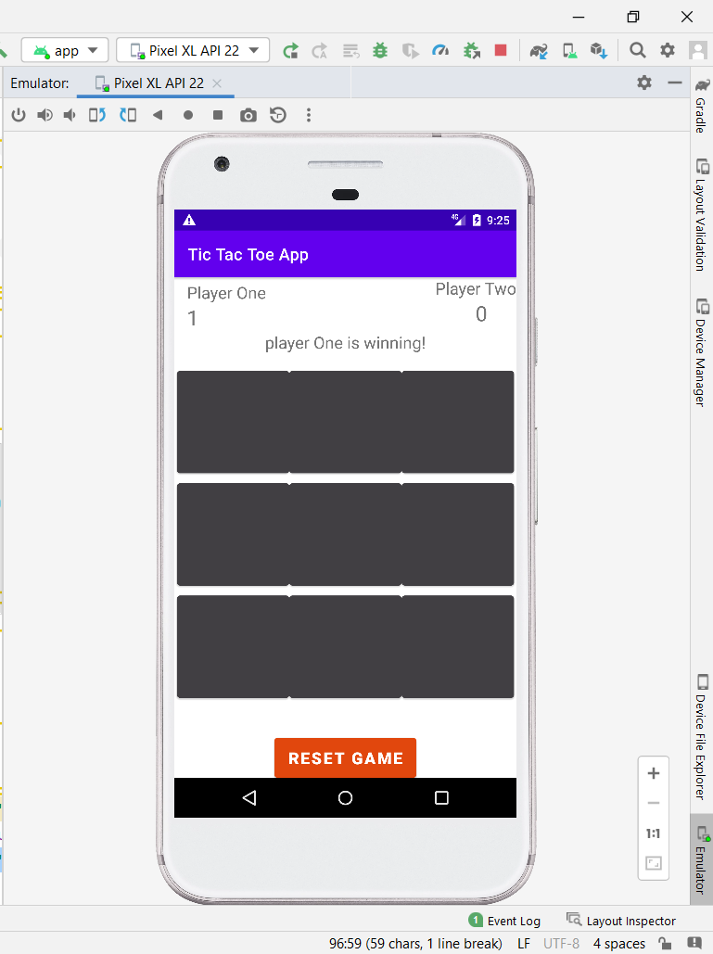

Fig.A.4 player One is winning